## 5.3 虚拟机整合算法

如前所述，OpenStack neat是基于前面几章中提出的动态虚拟机整合问题的方法，将问题分为4个子问题：（1）主机欠载检测；（2）主机过载检测；（3）虚拟机选择；（4）虚拟机放置。本节讨论一些实现的算法。

（以下算法使用的是在模拟器中的逻辑思路，在具体的openstack分布式应用中可能需要修改，若修改，请按照修改后的实际执行情况修改下面算法！！！）

首先完成neat自带的实验(参照论文openstack neat):

1. MAX-ITF algorithm—a baseline algorithm that never detects host overloads, leading to the maximum ITF for the host, where the algorithm is used.

2. The THR algorithm with the n parameter set to 2, and the CPU utilization threshold set to 0.8, 0.9, and 1.0

3. The LRR algorithm with the safety parameter set to 0.9, 1.0, and 1.1

4. The MHOD algorithm with the OTF parameter set to 0.2, 0.3, and 0.4

不需要每个系数都做，仅需要按照下面“名称”中的系数配置，总共做4个实验。

|  |  |  |  |  |  |
| --- | --- | --- | --- | --- | --- |
| 序号 | 名称 | 过载 | 轻载 | VM选择 | VM放置 |
| 1 | MAX-ITF | ---- | 4.1 | 4.3 | 4.4 |
| 2 | THR-0.9 | THR | 4.1 | 4.3 | 4.4 |
| 3 | LRR-0.9 | LRR | 4.1 | 4.3 | 4.4 |
| 4 | MHOD-0.3 | MHOD | 4.1 | 4.3 | 4.4 |

然后完成以下组合实验：

|  |  |  |  |  |  |
| --- | --- | --- | --- | --- | --- |
| 序号 | 名称 | 过载 | 轻载 | VM选择 | VM放置 |
| 1 | 静态阈值 | 1 | 1 | 1 | 1 |
| 2 | 动态阈值 | 2 | 2 | 1 | 1 |
| 3 | 线性回归 | 3 | 3 | 1 | 2 |
| 4 | 三阶马尔科夫 | 4 | 4 | 2 | 2 |
| 5 | 贝叶斯分类器1 | 5 | 6 | 1 | 2 |
| 6 | 决策树分类器 | 6 | 6 | 1 | 2 |
| 7 | 贝叶斯分类器2 | 5 | 6 | 2 | 2 |

### 5.3.1 主机过载探测

1）静态阈值法

设定为0.90。

算法5-1 基于静态阈值的主机过载探测算法

Algo.5-1 Algorithm of Host Overloading Detection based on static threshold

|  |  |
| --- | --- |
| **Input**: the host *host* | |
| **Output:** whether the host is overloaded, *boolean* | |
| 1: | return *host.getTotalRequestedMips() > 0.90∗ host.getTotalMips()*; |

2）动态阈值法

使用IQR方法。

算法5-2 基于IQR动态阈值的主机过载探测算法

Algo.5-2 Algorithm of Host Overloading Detection based on IQR dynamic threshold

|  |  |
| --- | --- |
| **Input**: the host *host* | |
| **Output:** whether the host is overloaded, *boolean* | |
| 1: | *n=12;* |
| 2: | *utilizationHistory = host.getutilizationHistory()*; |
| 3: | **if** *utilizationHistory.lenth<12* **then** |
| 4: | *Tu*=0.9; |
| 5: | **else** |
| 6: | *s=*1.5; |
| 7: | *Tu*=1-*s·IQR*; |
| 8: | **end if** |
| 9: | return *host.getTotalRequestedMips() > Tu ∗ host.getTotalMips()*; |

3）线性回归方法

目前只使用MAE(10)-MMT-2.5算法。

算法5-3 基于RobustSLR模型的主机过载探测算法

Algo.5-3 Algorithm of Host Overloading Detection based on RobustSLR model

|  |  |
| --- | --- |
| **Input**: the host *host* | |
| **Output:** whether the host is overloaded, *boolean* | |
| 1: | *n=10;* |
| 2: | *utilizationHistory = host.getutilizationHistory()*; |
| 3: | **if** *utilizationHistory.lenth < n* **then** |
| 4: | return *host.getTotalRequestedMips() > 0.90∗ host.getTotalMips()*; |
| 5: | **else** |
| 6: | *prediction = RobustSLR(utilizationHistory)*; |
| 7: | return *prediction* >= 1; |
| 8: | **end if** |

目前只使用回归算法中的MAE(10)-MMT-2.5算法。

算法2-1 健壮的线性回归预测算法

Algo.2-1 Algorithm of Robust Simple Linear Regression

|  |  |
| --- | --- |
| **Input**: the set of utilization history, *utilizationHistory*; | |
| **Output:** the prediction of utilization, *prediction.* | |
| 1: | *n = utilizationHistory.lenth*; |
| 2: | **for** *i* from 0 to *n-1* **do** |
| 3: | *x[i] = i + 1*; |
| 4: | *y[i] = utilizationHistory[i]*; |
| 5: | **end for** |
| 6: | ; |
| 7: | ; |
| 8: | calculate 和 according to equation (2-7); |
| 9: | **if** use *MSE* to revise **then** |
| 10: | calculate *MSE* according to equation (2-13); |
| 11: | calculate *prediction* according to equation (2-14); |
| 12: | **else if** use *RMSE* to revise **then** |
| 13: | calculate *RMSE* according to equation (2-15); |
| 14: | calculate *prediction* according to equation (2-16); |
| 15: | **else if** use *MAE(3)* to revise **then** |
| 16: | calculate *MAE(3)* according to equation (2-17); |
| 17: | calculate *prediction* according to equation (2-18); |
| 18: | **else if** use *MAE(10)* to revise **then** |
| 19: | calculate *MAE(10)* according to equation (2-17); |
| 20: | calculate *prediction* according to equation (2-18); |
| 21: | **else if** use *EWMAE(3)* to revise **then** |
| 22: | calculate *EWMAE(3)* according to equation (2-19); |
| 23: | calculate *prediction* according to equation (2-21); |
| 24: | **else if** use *EWMAE(10)* to revise **then** |
| 25: | calculate *EWMAE(10)* according to equation (2-20); |
| 26: | calculate *prediction* according to equation (2-21); |
| 27: | **else if** use  to revise **then** |
| 28: | calculateaccording to equation (2-22); |
| 29: | calculate *prediction* according to equation (2-23); |
| 30: | **else if** use *95%CIslope* to revise **then** |
| 31: | calculate *95%CIslope* according to equation (2-24) using *α* = 0.05; |
| 32: | calculate *prediction* according to equation (2-25); |
| 33: | **else** |
| 34: | we should not be here, report some error; |
| 35: | **end if** |
| 36: | **retrun** *prediction*． |

4）三阶马尔科夫链方法

算法3-2基于HS3MC模型的主机状态探测算法

Algo.3-2 Algorithm of Host State Detection based on HS3MC model

|  |  |
| --- | --- |
| **Input**: 主机*host*, 转换矩阵***R***, 探测类型*type*； | |
| **Output:** 主机状态*boolean*． | |
| 1: | *n=*3； |
| 2: | *utilizationHistory = host.getutilizationHistory()*; |
| 3: | **if** *utilizationHistory.lenth<12* **then** |
| 4: | *Tu*=0.90; |
| 5: | *Tl*=0.17; |
| 6: | **else** |
| 7: | *Tu*=1-*1.5·IQR*; |
| 8: | *Tl*=0.25*(1-*1.5·IQR*); |
| 9: | **end if** |
| 10: | ***X***=(*x0, x1, x2*); |
| 11: | **for** *I* from 0 to *n-1* **do** |
| 12: | **if** *xi* ≤ *Tl* **then** |
| 13: | *yi* =1; |
| 14: | **else if** *xi* ≥ *Tu* **then** |
| 15: | *yi* =3; |
| 16: | **else** |
| 17: | *yi* =2; |
| 18: | **end if** |
| 19: | **end for** |
| 20: | ***Y***=(*y0, y1, y2*); |
| 21: | calculate ,, according to ***R***; |
| 22: | **if** *type* is *overloaded* **then** |
| 23: | **if** >∧> **then** |
| 24: | **return** true; |
| 25: | **else** |
| 26: | **return** false; |
| 27: | **end if** |
| 28: | **else** |
| 29: | **if** >∧> **then** |
| 30: | **return** true; |
| 31: | **else** |
| 32: | **return** false; |
| 33: | **end if** |
| 34: | **end if** |

算法3-1 三阶马尔科夫链转换矩阵构造算法

Algo.3-1 Algorithm of 3-order Markov Chain Transition Matrix Build

|  |  |
| --- | --- |
| **Input**: 训练数据集合***D*** | |
| **Output:** 转换矩阵***R*** | |
| 1: | *m=****D****.length*； |
| 2: | **for** *k* from 4 to *m* **do** |
| 3: | **if** *k<12* **then** |
| 4: | *Tu*=0.90; |
| 5: | *Tl*=0.17; |
| 6: | **else** |
| 7: | *Tu*=1-*IQR*; |
| 8: | *Tl*=0.25*(1-*IQR*); |
| 9: | **end if** |
| 10: | ***X***=(*xk-3, xk-2, xk-1, xk*); |
| 11: | **for** *j* from 3 to *m* **do** |
| 12: | **if** *xk-j* ≤ *Tl* **then** |
| 13: | *yk-j*=1; |
| 14: | **else if** *xk-j* ≥ *Tu* **then** |
| 15: | *yk-j*=3; |
| 16: | **else** |
| 17: | *yk-j*=2; |
| 18: | **end if** |
| 19: | **end for** |
| 20: | ***Y***=(*yk-3, yk-2, yk-1, yk*)=(*i3, i2, i1, i0*); |
| 21: | ++; |
| 22: | **end for** |
| 23: |  |
| 24: | calculate ***R*** according to equation (3); |
| 25: | **retrun** ***R***． |

也可以直接使用下面的结果：

R=

|  |  |  |  |
| --- | --- | --- | --- |
|  | 1（轻载） | 2（正常） | 3（过载） |
| 0 | 0.965165 | 0.034299 | 0.000536 |
| 1 | 0.729800 | 0.267658 | 0.002541 |
| 2 | 0.644444 | 0.195556 | 0.160000 |
| 3 | 0.758803 | 0.238561 | 0.002637 |
| 4 | 0.455833 | 0.539722 | 0.004444 |
| 5 | 0.463415 | 0.426829 | 0.109756 |
| 6 | 0.705882 | 0.156863 | 0.137255 |
| 7 | 0.464286 | 0.404762 | 0.130952 |
| 8 | 0.297297 | 0.216216 | 0.486486 |
| 9 | 0.746724 | 0.250447 | 0.002829 |
| 10 | 0.461057 | 0.534028 | 0.004914 |
| 11 | 0.388235 | 0.364706 | 0.247059 |
| 12 | 0.497861 | 0.497308 | 0.004831 |
| 13 | 0.132676 | 0.848201 | 0.019123 |
| 14 | 0.050378 | 0.648615 | 0.301008 |
| 15 | 0.541176 | 0.270588 | 0.188235 |
| 16 | 0.055631 | 0.704206 | 0.240163 |
| 17 | 0.032110 | 0.442661 | 0.525229 |
| 18 | 0.680180 | 0.180180 | 0.139640 |
| 19 | 0.357143 | 0.442857 | 0.200000 |
| 20 | 0.304348 | 0.108696 | 0.586957 |
| 21 | 0.451613 | 0.376344 | 0.172043 |
| 22 | 0.050697 | 0.697085 | 0.252218 |
| 23 | 0.020619 | 0.481959 | 0.497423 |
| 24 | 0.336842 | 0.157895 | 0.505263 |
| 25 | 0.029083 | 0.527964 | 0.442953 |
| 26 | 0.066934 | 0.310576 | 0.622490 |

5）贝叶斯分类器方法

Priori={0.990458,0.009542}

Double[][] cp={{0.000357,0.000168,0.000276,0.000406,0.000992,0.001073,0.001136,0.001222,0.001292,0.001363},{0.642226,0.097315,0.187919,0.267617,0.491331,0.509228,0.524049,0.546421,0.577181,0.619407}};

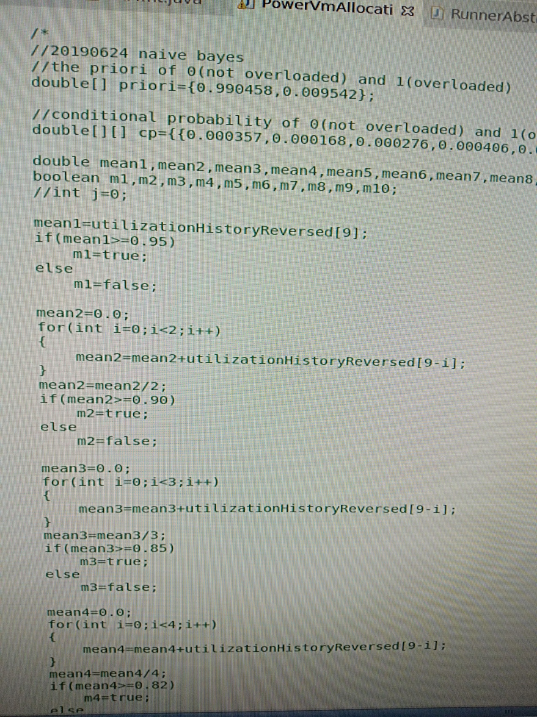

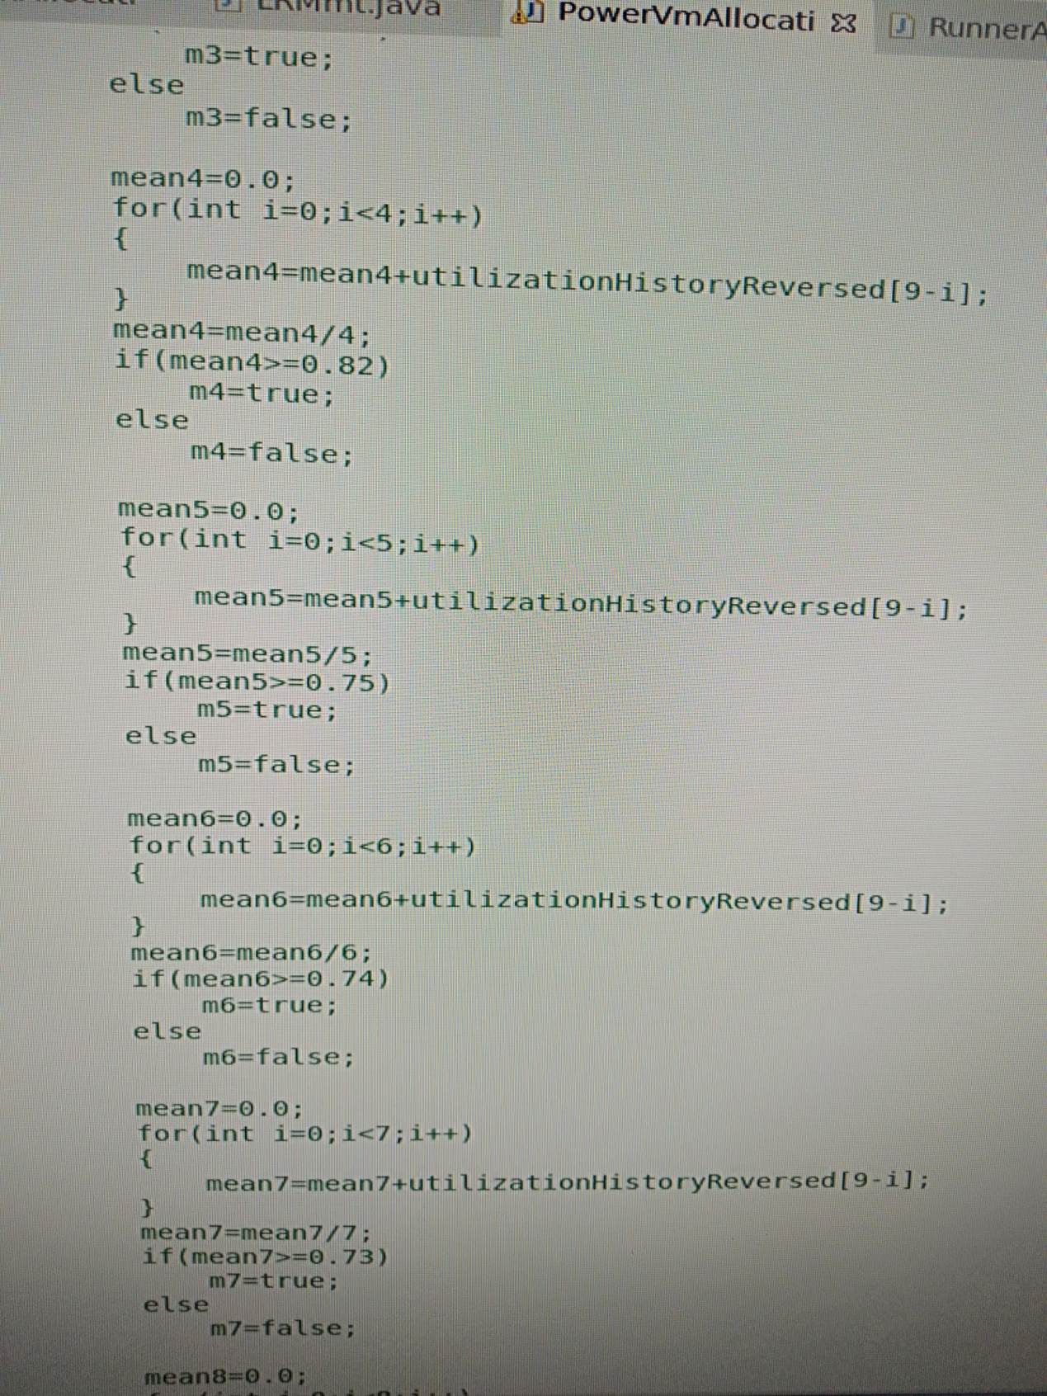

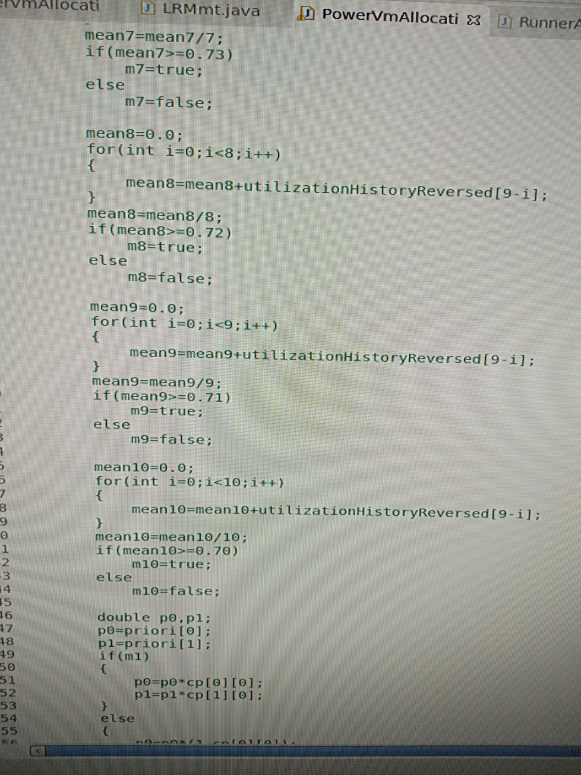

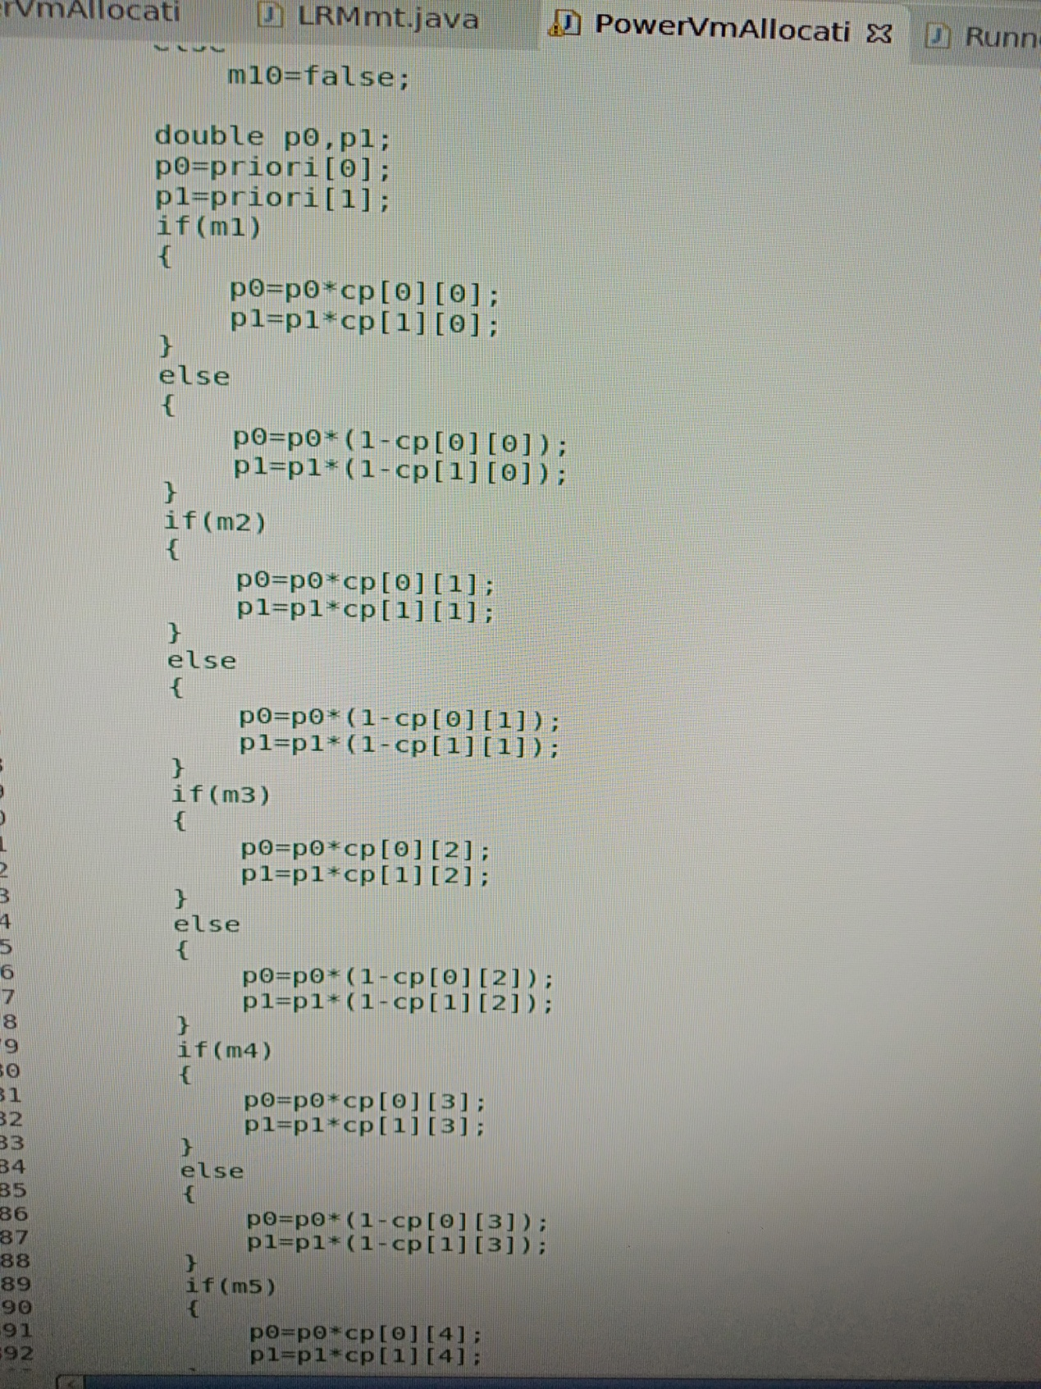

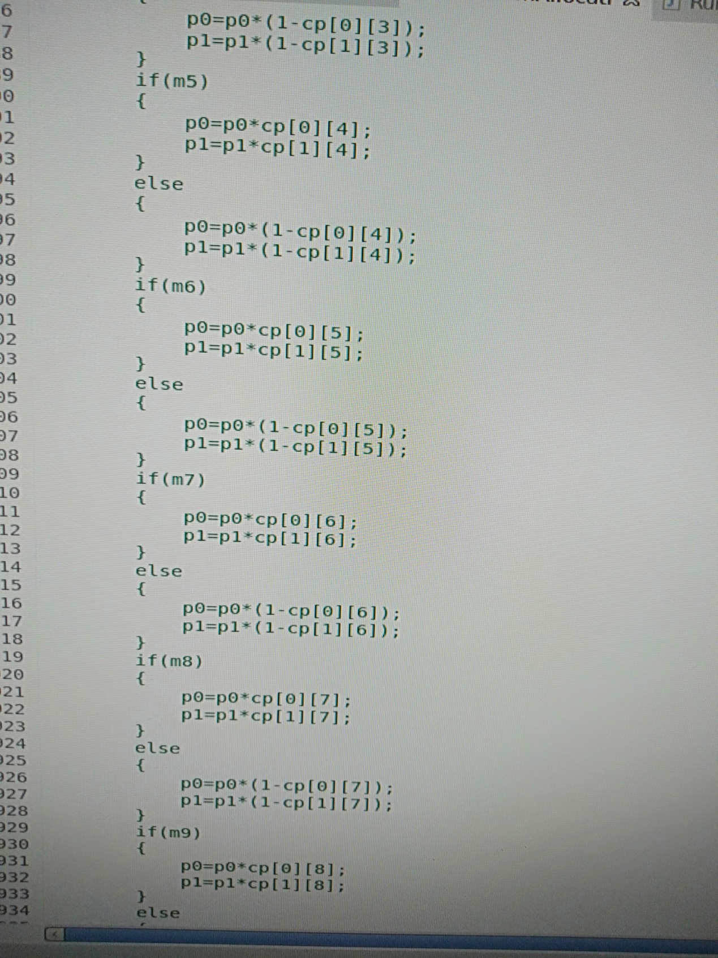

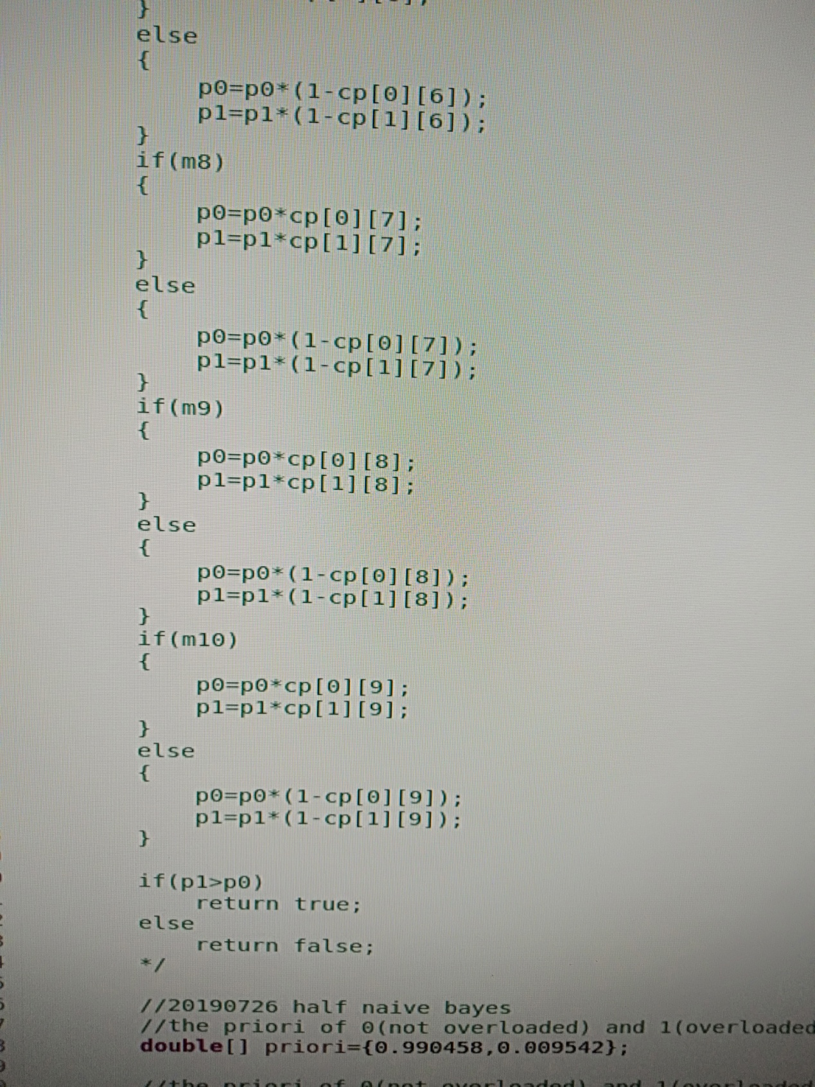

算法4-3 基于HSNBC模型的主机过载探测算法

Algo.4-3 Algorithm of Host Overloading Detection based on HSNBC model

|  |  |
| --- | --- |
| **Input**: the host *host* | |
| **Output:** whether the host is overloaded, *boolean* | |
| 1: | *n=10;* |
| 2: | *utilizationHistory = host.getutilizationHistory()*; |
| 3: | **if** *utilizationHistory.lenth < n* **then** |
| 4: | return *host.getTotalRequestedMips() > 0.90∗ host.getTotalMips()*; |
| 5: | **else** |
| 6: | **for** *i = 0* to *n − 1* **do** |
| 7: | *x[i] = utilizationHistory[n − i − 1]*; |
| 8: | **end for** |
| 9: | **for** *i = 0* to *n − 1* **do** |
| 10: | ; |
| 11: | **end for** |
| 12: | **for** *i = 0* to *n − 1* **do** |
| 13: | **if** *y[i]>Oi***then** |
| 14: | *Z[i]=1*; |
| 15: | **else** |
| 16: | *Z[i]=0*; |
| 17: | **end if** |
| 18: | **end for** |
| 19: | *Z = (z[0], z[1], ..., z[n − 1])*; |
| 20: | *NBC = HSNBCBuild(D, O)*; |
| 21: | ; |
| 22: | ; |
| 23: | ; |
| 24: | ; |
| 25: | **if**  **then** |
| 26: | **return** true; |
| 27: | **else** |
| 28: | **return** false; |
| 29: | **end if** |
| 30: | **end if** |

6）二叉决策树方法

算法4-4 基于HSBDTP模型的主机过载探测算法

Algo.4-4 Algorithm of Host Overloading Detection based on HSBDTP model

|  |  |
| --- | --- |
| **Input**: the host *host* | |
| **Output:** whether the host is overloaded, *boolean* | |
| 1: | *n=10;* |
| 2: | *utilizationHistory = host.getutilizationHistory()*; |
| 3: | **if** *utilizationHistory.lenth < n* **then** |
| 4: | return *host.getTotalRequestedMips() > 0.90∗ host.getTotalMips()*; |
| 5: | **else** |
| 6: | **for** *i = 0* to *n − 1* **do** |
| 7: | *x[i] = utilizationHistory[n − i − 1]*; |
| 8: | **end for** |
| 9: | **for** *i = 0* to *n − 1* **do** |
| 10: | ; |
| 11: | **end for** |
| 12: | *Y = (y[0], y[1], ..., y[n − 1])*; |
| 13: | *HOBDTree = HSBDTreeBuild(D, F, O)*; |
| 14: | *class = HOBDTree(Y)*; |
| 15: | **if** *class == 1* **then** |
| 16: | **return** true; |
| 17: | **else** |
| 18: | **return** false; |
| 19: | **end if** |
| 20: | **end if** |

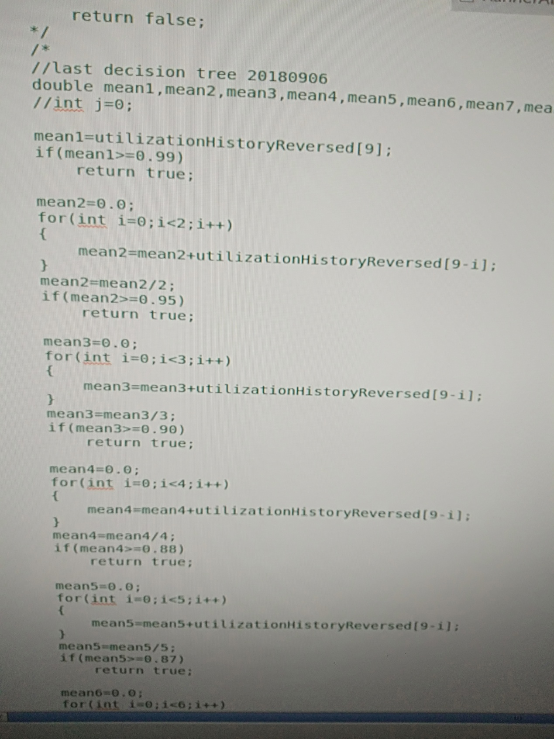

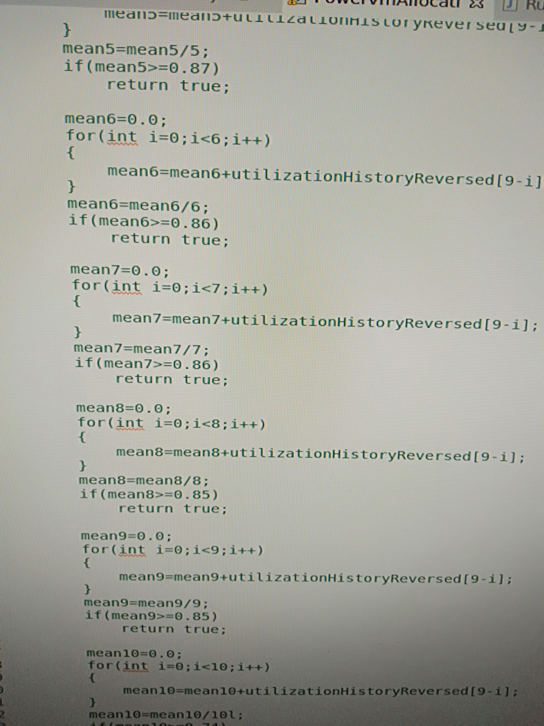

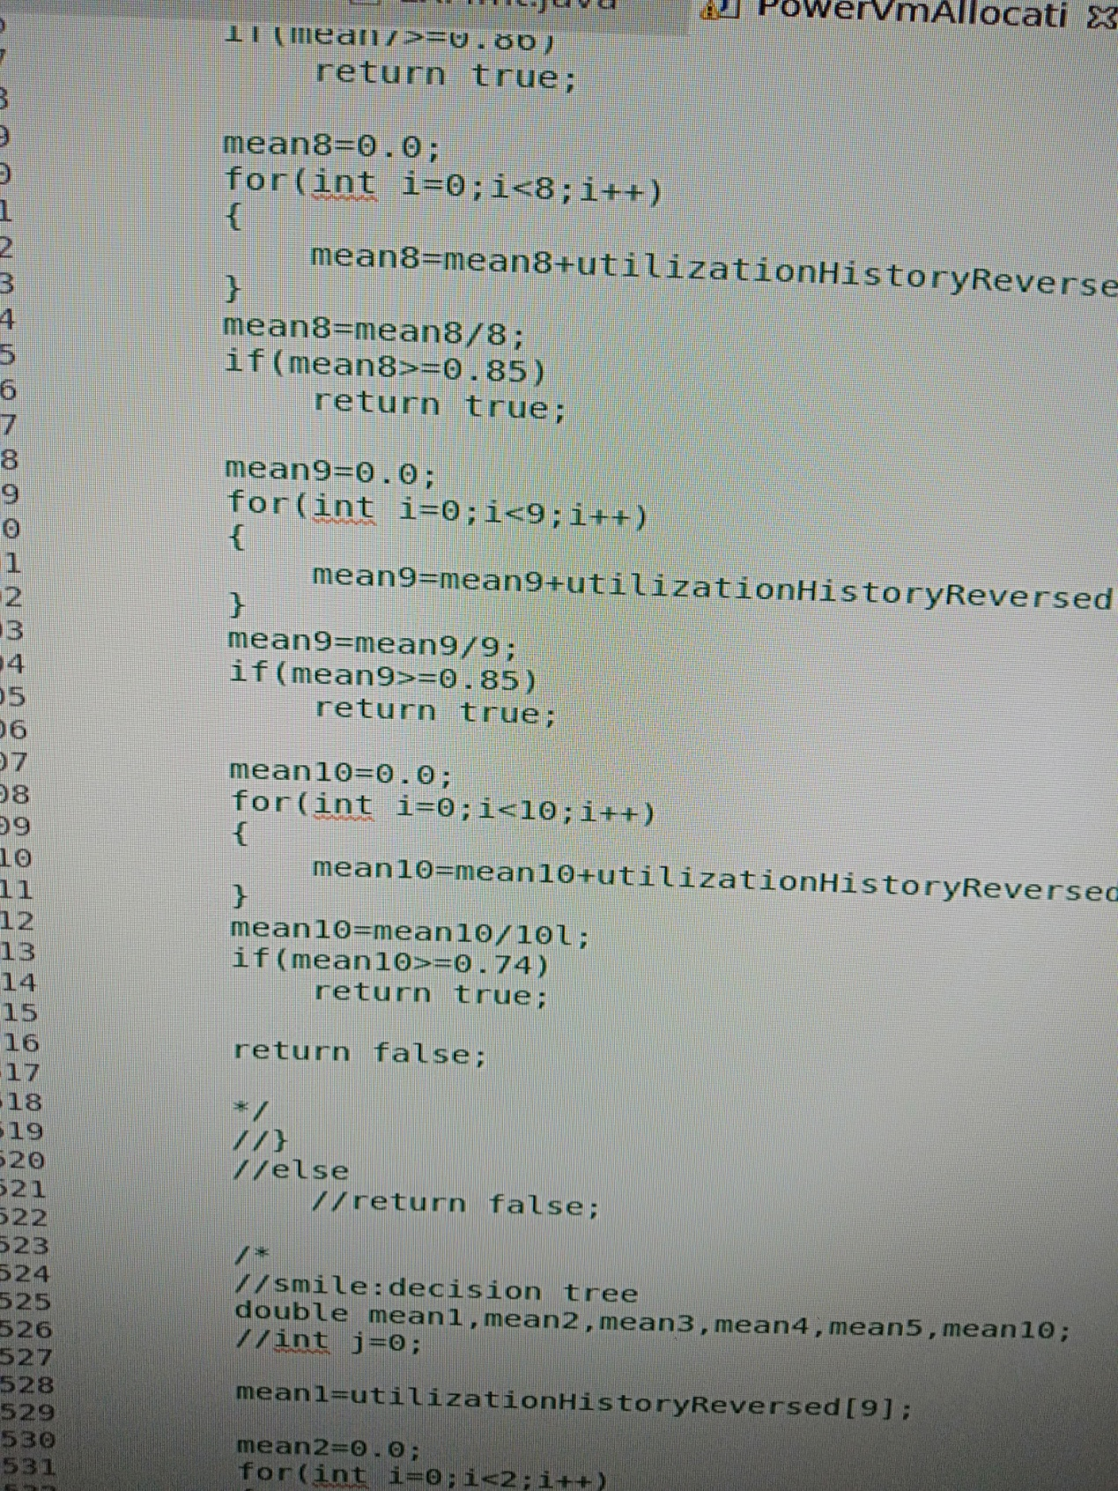

### 5.3.2 主机轻载探测

1）静态阈值法

设定为0.10

算法2-2 基于静态阈值的主机过载探测算法

Algo.2-2 Algorithm of Host Overloading Detection based on static threshold

|  |  |
| --- | --- |
| **Input**: the host *host* | |
| **Output:** whether the host is overloaded, *boolean* | |
| 1: | return *host.getTotalRequestedMips() < 0.10∗ host.getTotalMips()*; |

2）动态阈值法

使用IQR方法

算法2-2 基于IQR动态阈值的主机过载探测算法

Algo.2-2 Algorithm of Host Overloading Detection based on IQR dynamic threshold

|  |  |
| --- | --- |
| **Input**: the host *host* | |
| **Output:** whether the host is overloaded, *boolean* | |
| 1: | *n=12;* |
| 2: | *utilizationHistory = host.getutilizationHistory()*; |
| 3: | **if** *utilizationHistory.lenth<12* **then** |
| 4: | *Tl*=0.1; |
| 5: | **else** |
| 6: | *s=*1.5; |
| 7: | *Tl*=0.25*(1-*s·IQR*); |
| 8: | **end if** |
| 9: | return *host.getTotalRequestedMips() < Tl ∗ host.getTotalMips()*; |

3）线性回归方法

目前只使用MAE(10)-MMT-2.5算法。

算法2-3 基于RobustSLR模型的主机轻载探测算法

Algo.2-3 Algorithm of Host Underloading Detection based on RobustSLR model

|  |  |
| --- | --- |
| **Input**: the host *host* | |
| **Output:** whether the host is underloaded, *boolean* | |
| 1: | *n=12;* |
| 2: | *utilizationHistory = host.getutilizationHistory()*; |
| 3: | **if** *utilizationHistory.lenth < n* **then** |
| 4: | return *host.getTotalRequestedMips() < 0.10∗ host.getTotalMips()*; |
| 5: | **else** |
| 6: | *s*=2.5; |
| 7: | ; |
| 8: | *prediction = RobustSLR(utilizationHistory)*; |
| 9: | return *prediction < Tl*; |
| 10: | **end if** |

4）三阶马尔科夫链方法

算法3-2基于HS3MC模型的主机状态探测算法

Algo.3-2 Algorithm of Host State Detection based on HS3MC model

|  |  |
| --- | --- |
| **Input**: 主机*host*, 转换矩阵***R***, 探测类型*type*； | |
| **Output:** 主机状态*boolean*． | |
| 1: | *n=*3； |
| 2: | *utilizationHistory = host.getutilizationHistory()*; |
| 3: | **if** *utilizationHistory.lenth<12* **then** |
| 4: | *Tu*=0.90; |
| 5: | *Tl*=0.17; |
| 6: | **else** |
| 7: | *Tu*=1-*1.5·IQR*; |
| 8: | *Tl*=0.25*(1-*1.5·IQR*); |
| 9: | **end if** |
| 10: | ***X***=(*x0, x1, x2*); |
| 11: | **for** *I* from 0 to *n-1* **do** |
| 12: | **if** *xi* ≤ *Tl* **then** |
| 13: | *yi* =1; |
| 14: | **else if** *xi* ≥ *Tu* **then** |
| 15: | *yi* =3; |
| 16: | **else** |
| 17: | *yi* =2; |
| 18: | **end if** |
| 19: | **end for** |
| 20: | ***Y***=(*y0, y1, y2*); |
| 21: | calculate ,, according to ***R***; |
| 22: | **if** *type* is *overloaded* **then** |
| 23: | **if** >∧> **then** |
| 24: | **return** true; |
| 25: | **else** |
| 26: | **return** false; |
| 27: | **end if** |
| 28: | **else** |
| 29: | **if** >∧> **then** |
| 30: | **return** true; |
| 31: | **else** |
| 32: | **return** false; |
| 33: | **end if** |
| 34: | **end if** |

算法3-1 三阶马尔科夫链转换矩阵构造算法

Algo.3-1 Algorithm of 3-order Markov Chain Transition Matrix Build

|  |  |
| --- | --- |
| **Input**: 训练数据集合***D*** | |
| **Output:** 转换矩阵***R*** | |
| 1: | *m=****D****.length*； |
| 2: | **for** *k* from 4 to *m* **do** |
| 3: | **if** *k<12* **then** |
| 4: | *Tu*=0.90; |
| 5: | *Tl*=0.17; |
| 6: | **else** |
| 7: | *Tu*=1-*IQR*; |
| 8: | *Tl*=0.25*(1-*IQR*); |
| 9: | **end if** |
| 10: | ***X***=(*xk-3, xk-2, xk-1, xk*); |
| 11: | **for** *j* from 3 to *m* **do** |
| 12: | **if** *xk-j* ≤ *Tl* **then** |
| 13: | *yk-j*=1; |
| 14: | **else if** *xk-j* ≥ *Tu* **then** |
| 15: | *yk-j*=3; |
| 16: | **else** |
| 17: | *yk-j*=2; |
| 18: | **end if** |
| 19: | **end for** |
| 20: | ***Y***=(*yk-3, yk-2, yk-1, yk*)=(*i3, i2, i1, i0*); |
| 21: | ++; |
| 22: | **end for** |
| 23: |  |
| 24: | calculate ***R*** according to equation (3); |
| 25: | **retrun** ***R***． |

也可以直接使用下面的结果：

R=

|  |  |  |  |
| --- | --- | --- | --- |
|  | 1（轻载） | 2（正常） | 3（过载） |
| 0 | 0.965165 | 0.034299 | 0.000536 |
| 1 | 0.729800 | 0.267658 | 0.002541 |
| 2 | 0.644444 | 0.195556 | 0.160000 |
| 3 | 0.758803 | 0.238561 | 0.002637 |
| 4 | 0.455833 | 0.539722 | 0.004444 |
| 5 | 0.463415 | 0.426829 | 0.109756 |
| 6 | 0.705882 | 0.156863 | 0.137255 |
| 7 | 0.464286 | 0.404762 | 0.130952 |
| 8 | 0.297297 | 0.216216 | 0.486486 |
| 9 | 0.746724 | 0.250447 | 0.002829 |
| 10 | 0.461057 | 0.534028 | 0.004914 |
| 11 | 0.388235 | 0.364706 | 0.247059 |
| 12 | 0.497861 | 0.497308 | 0.004831 |
| 13 | 0.132676 | 0.848201 | 0.019123 |
| 14 | 0.050378 | 0.648615 | 0.301008 |
| 15 | 0.541176 | 0.270588 | 0.188235 |
| 16 | 0.055631 | 0.704206 | 0.240163 |
| 17 | 0.032110 | 0.442661 | 0.525229 |
| 18 | 0.680180 | 0.180180 | 0.139640 |
| 19 | 0.357143 | 0.442857 | 0.200000 |
| 20 | 0.304348 | 0.108696 | 0.586957 |
| 21 | 0.451613 | 0.376344 | 0.172043 |
| 22 | 0.050697 | 0.697085 | 0.252218 |
| 23 | 0.020619 | 0.481959 | 0.497423 |
| 24 | 0.336842 | 0.157895 | 0.505263 |
| 25 | 0.029083 | 0.527964 | 0.442953 |
| 26 | 0.066934 | 0.310576 | 0.622490 |

5）贝叶斯分类器方法

算法4-5 基于HSNBC模型的主机轻载探测算法

Algo.4-5 Algorithm of Host Underloading Detection based on HSNBC model

|  |  |
| --- | --- |
| **Input**: the host *host* | |
| **Output:** whether the host is overloaded, *boolean* | |
| 1: | *n=10;* |
| 2: | *utilizationHistory = host.getutilizationHistory()*; |
| 3: | **if** *utilizationHistory.lenth < n* **then** |
| 4: | return *host.getTotalRequestedMips() < 0.10∗ host.getTotalMips()*; |
| 5: | **else** |
| 6: | **for** *i = 0* to *n − 1* **do** |
| 7: | *x[i] = utilizationHistory[n − i − 1]*; |
| 8: | **end for** |
| 9: | **for** *i = 0* to *n − 1* **do** |
| 10: | ; |
| 11: | **end for** |
| 12: | **for** *i = 0* to *n − 1* **do** |
| 13: | **if** *y[i]>Oi***then** |
| 14: | *Z[i]=1*; |
| 15: | **else** |
| 16: | *Z[i]=0*; |
| 17: | **end if** |
| 18: | **end for** |
| 19: | *Z = (z[0], z[1], ..., z[n − 1])*; |
| 20: | *NBC = HSNBCBuild(D, U)*; |
| 21: | ; |
| 22: | ; |
| 23: | ; |
| 24: | ; |
| 25: | **if**  **then** |
| 26: | **return** true; |
| 27: | **else** |
| 28: | **return** false; |
| 29: | **end if** |
| 30: | **end if** |

6）二叉决策树方法

算法4-6 基于HSBDTP模型的主机轻载探测算法

Algo.4-6 Algorithm of Host Underloading Detection based on HSBDTP model

|  |  |
| --- | --- |
| **Input**: the host *host* | |
| **Output:** whether the host is overloaded, *boolean* | |
| 1: | *n=10;* |
| 2: | *utilizationHistory = host.getutilizationHistory()*; |
| 3: | **if** *utilizationHistory.lenth < n* **then** |
| 4: | return *host.getTotalRequestedMips() < 0.10∗ host.getTotalMips()*; |
| 5: | **else** |
| 6: | **for** *i = 0* to *n − 1* **do** |
| 7: | *x[i] = utilizationHistory[n − i − 1]*; |
| 8: | **end for** |
| 9: | **for** *i = 0* to *n − 1* **do** |
| 10: | ; |
| 11: | **end for** |
| 12: | *Y = (y[0], y[1], ..., y[n − 1])*; |
| 13: | *HUBDTree = HSBDTreeBuild(D, F, U)*; |
| 14: | *class = HUBDTree(Y)*; |
| 15: | **if** *class == 1* **then** |
| 16: | **return** true; |
| 17: | **else** |
| 18: | **return** false; |
| 19: | **end if** |
| 20: | **end if** |

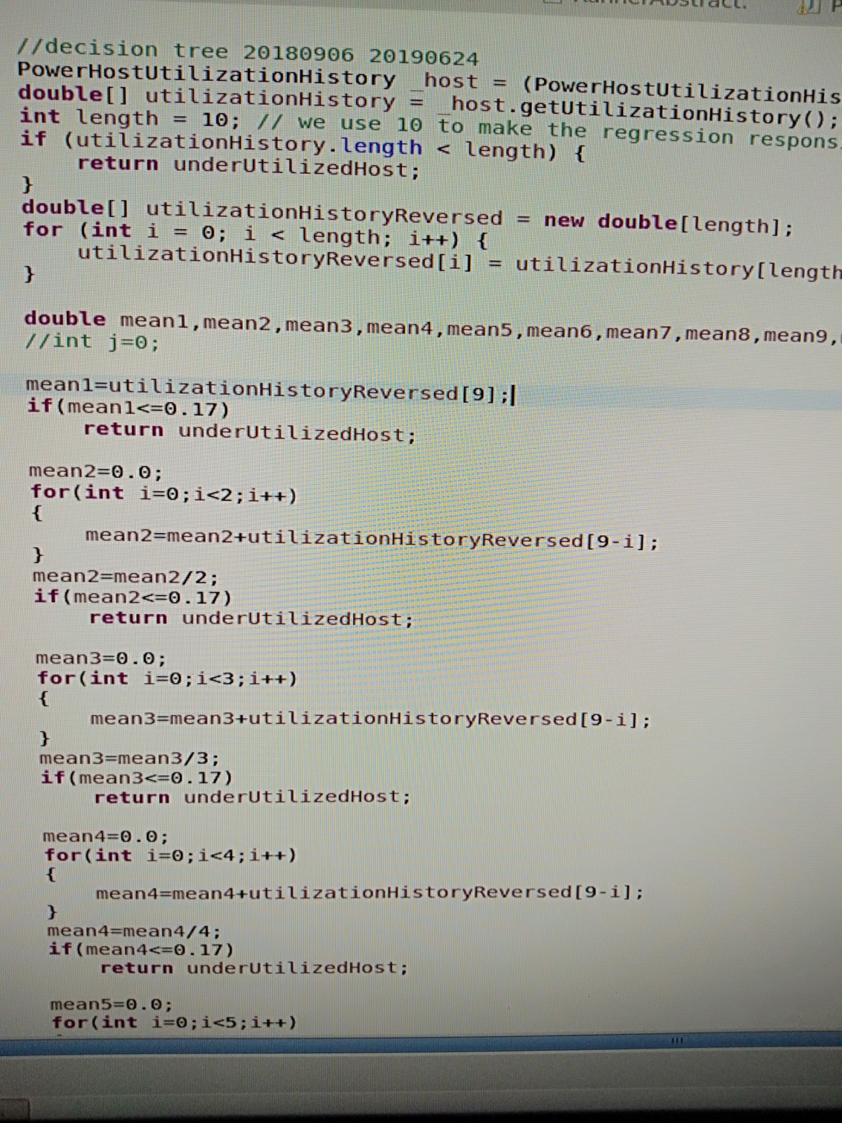

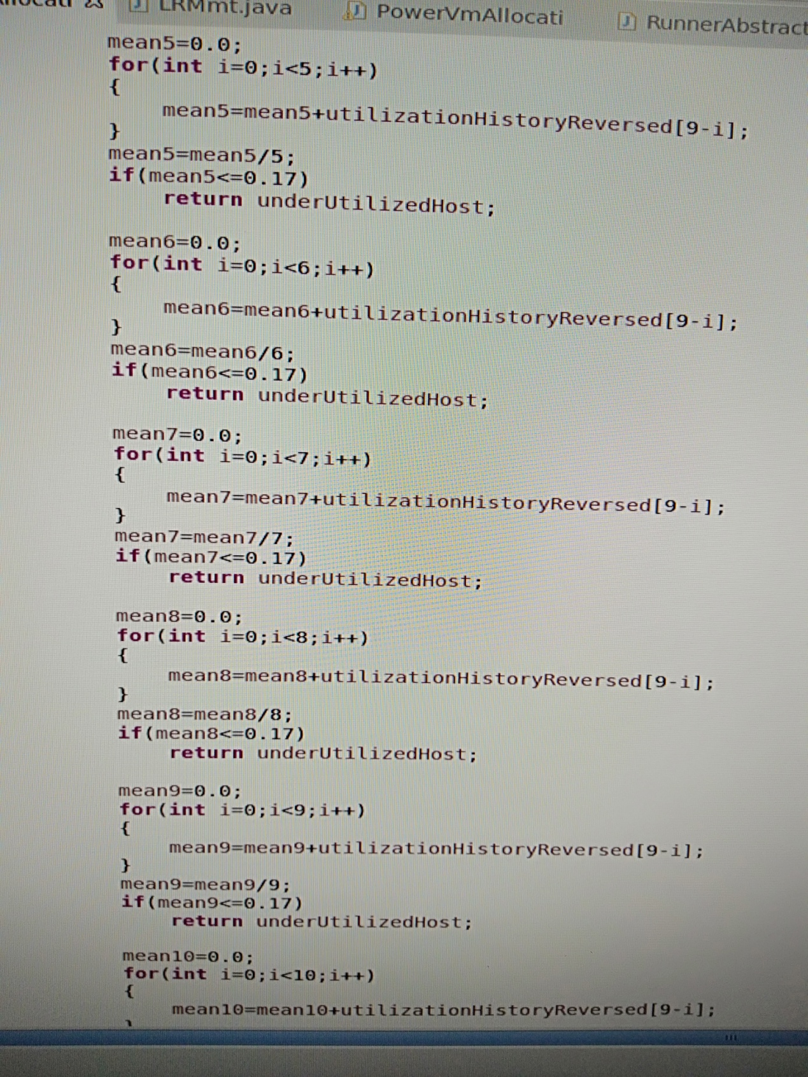

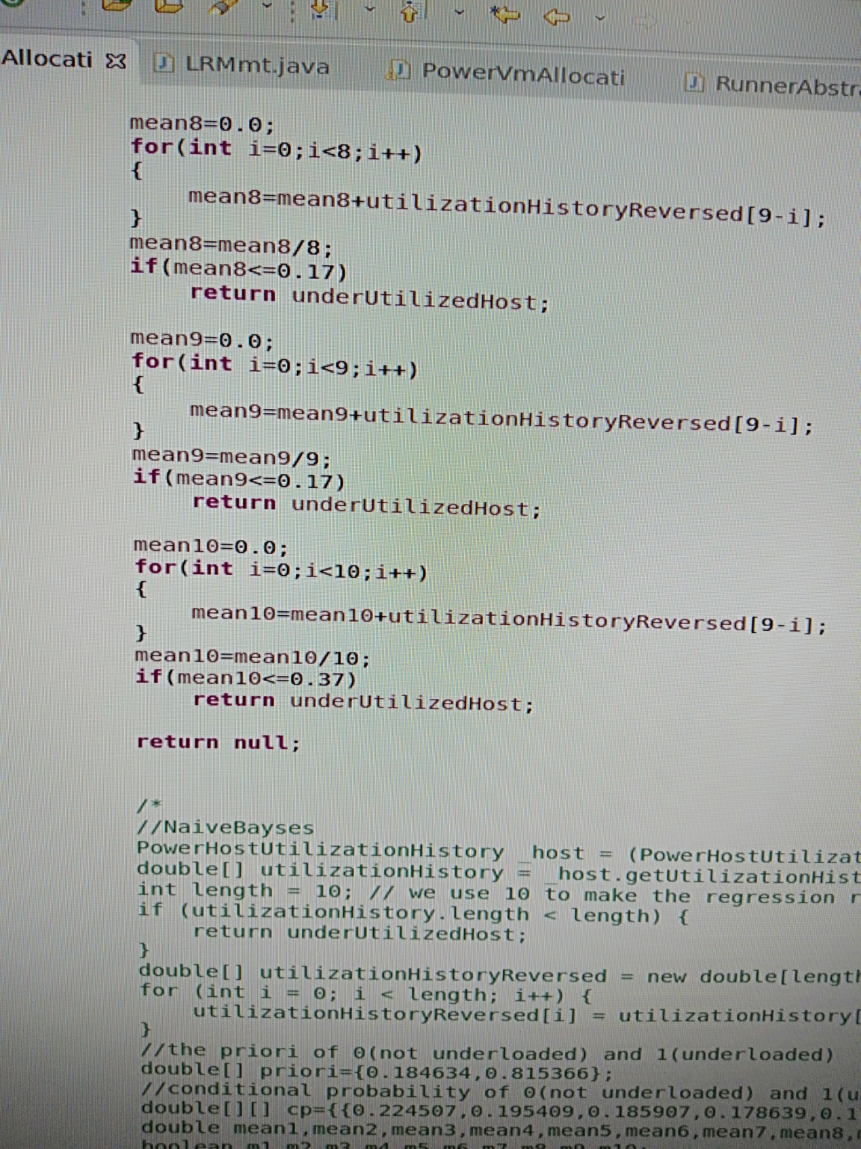

### 5.3.3 虚拟机选择

1）MMT

目前仅使用MMT策略。

2）3MIN

r=1.0

算法3-3最小迁移、最小CPU和最小RAM虚拟机选择算法

Algo.3-3 Algorithm of MIN migration MIN CPU and MIN RAM VM selection

|  |  |
| --- | --- |
| **Input**: 主机*host*； | |
| **Output:** 待迁移的虚拟机*vmToMigrate*． | |
| 1: | *migratableVms = host.getVms()*； |
| 2: | **if** *migratableVms* is empty **then** |
| 3: | **return** *null*; |
| 4: | **end if** |
| 5: | *vmToMigrate=null;* |
| 6: | *hostNeedMips = vmsRequestedTotalMips − r ∗ host.getTotalMips()*; |
| 7: | if *hostNeedMips<0* |
| 8: | **return** *null*; |
| 9: | **else** |
| 10: | *minMetric = Double.MAX*; |
| 11: | **for** *vm* in *migratableVms* **do** |
| 12: | **if** task on *vm* will finish at next time **then** |
| 13: | continue; |
| 14: | **end if** |
| 15: | *metric = vm.getMips() ∗ vm.getRam()*; |
| 16: | **if** *metric<* *minMetric* ∧*vm.getMips()>hostNeedMips* **then** |
| 17: | *minMetric = metric;* |
| 18: | *vmToMigrate = vm;* |
| 19: | **end if** |
| 20: | **end for** |
| 21: | **if** *vmToMigrate* is *null* **then** |
| 22: | *vmToMigrate =* *getMaxMipsVm(migratableVms);* |
| 23: | **end if** |
| 24: | **end if** |
| 25: | **return** *vmToMigrate*． |

### 5.3.4 虚拟机放置

1）Power Aware Best Fit Decreasing

算法4-8能耗感知最好适应降低虚拟机放置算法

Algo.4-8 Algorithm of Power Aware Best Fit Decreasing

|  |  |
| --- | --- |
| **Input**: 主机列表*hostList*, 虚拟机列表*vmList*； | |
| **Output:** 虚拟机放置字典*allocation*． | |
| 1: | *vmList.sortDecreasingUtilization()*； |
| 2: | **for** *vmList* contain *vm* **do** |
| 3: | *min=MAX*; |
| 4: | *allocatedHost=null*; |
| 5: | **for** *hostList* contain *host* **do** |
| 6: | **if** *host* can allocate resources for *vm* **then** |
| 7: | *power = getPower(host, vm)*; |
| 8: | **if** *power<min* **then** |
| 9: | *allocatedHost = host*; |
| 10: | *min = power*; |
| 11: | **end if** |
| 12: | **end if** |
| 13: | **if** *allocatedHost* is not *null* **then** |
| 14: | *allocation.add(vm, allocatedHost)*; |
| 15: | **end if** |
| 16: | **end for** |
| 17: | **end for** |
| 18: | **return** *allocation*． |

2）improved Power Aware Best Fit Decreasing

HOD和HUD算法分别对应使用上文用到的过载探测和轻载探测算法。

算法4-8基于模型的能耗感知最好适应降低虚拟机放置算法

Algo.4-8 Algorithm of Power Aware Best Fit Decreasing

|  |  |
| --- | --- |
| **Input**: 主机列表*hostList*, 虚拟机列表*vmList*； | |
| **Output:** 虚拟机放置字典*allocation*． | |
| 1: | *vmList.sortDecreasingUtilization()*； |
| 2: | **for** *vmList* contain *vm* **do** |
| 3: | *min=MAX*; |
| 4: | *allocatedHost=null*; |
| 5: | **for** *hostList* contain *host* **do** |
| 6: | **if** *HOD(host)* return ture **then** |
| 7: | continue; |
| 8: | **end if** |
| 9: | **if** *HUD(host)* return ture **then** |
| 10: | continue; |
| 11: | **end if** |
| 12: | **if** *host* can allocate resources for *vm* **then** |
| 13: | *power = getPower(host, vm)*; |
| 14: | **if** *power<min* **then** |
| 15: | *allocatedHost = host*; |
| 16: | *min = power*; |
| 17: | **end if** |
| 18: | **end if** |
| 19: | **if** *allocatedHost* is not *null* **then** |
| 20: | *allocation.add(vm, allocatedHost)*; |
| 21: | **end if** |
| 22: | **end for** |
| 23: | **end for** |
| 24: | **return** *allocation*． |

## 5.4 性能评估

### 5.4.1实验安装

参照下图介绍测试平台：

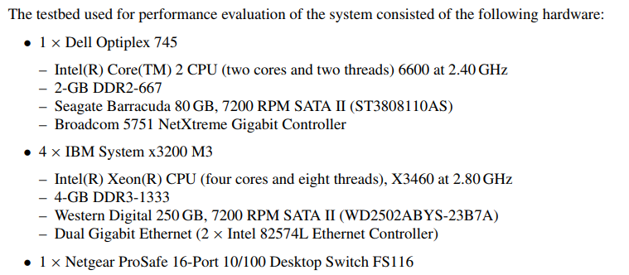

### 5.4.2 工作负载数据

当前暂时只使用PlanetLab数据集。简介数据筛选原则和最终使用的具体数据情况。

### 5.4.3性能度量

使用以下四个度量：

1. 聚合空闲时间比（aggregated idle time fraction）



H代表主机集合，是主机h的空闲时间，是主机h的整个活跃时间。

2. 聚合过载时间比（aggregated overload time fraction）



H代表主机集合，是主机h在阈值下的过载时间，是主机h的整个忙（非空闲）时间。

3. 能耗

4. 虚拟机迁移数量（VM migrations）

### 5.5.4 实验结果和分析

参照以下三个表，只要一个值就可以，不用计算CI

